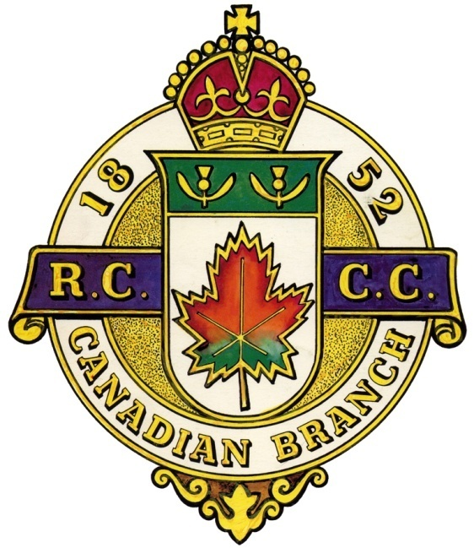
The CANADIAN BRANCH La FILIALE CANADIENNE

of the du

ROYAL CALEDONIAN CURLING CLUB
GENERAL MEETING
RÉUNION GÉNÉRALE
Pointe Claire Curling Club, 250 Lanthier Ave, Pointe Claire, Qc
Thursday, September 5, 2019 7:30 pm Vendredi le 5bSeptembre 2019 1930h

AGENDA / ORDRE DU JOUR

- Call to Order / Ouverture de l’assemblée
- Opening Remarks / Bienvenue
- Invocation / Invocation
- Moment of Silence / Un moment de recueillement
- Notice of Meeting / Avis du convocation
- Special Guests / Invités spéciaux
- Roll Call / Presences
- Agenda / L’ordre du jour
  - Motion to accept / Adoption de l’ordre du jour
- Minutes of the last meeting (May 31 2019)
Procès-verbal de la dernière assemblée (le 31 Mai 2019)
- Business arising from the minutes
Retour sur le procès-verbal
  - New events and schedule
  - Affiliation with Royal Caledonia Curling Club
  - Building Honorary Members web page
  - RCCC ties for Branch executives
  - 1,000th Quebec Challenge
- Correspondance / Correspondence
- Regional Reports / Rapports régionaux
  - Montreal (District 1)
  - Outaouais & Ontario (District 2)
  - South West (District 3)
  - Mauricie (District 4)
  - L’Estrie (District 5)
  - Other
- Standing Committee Reports / Rapports des comités permanent
  - Finance – Robert Dods
  - Scheduling – Brock MacDonald
  - Competitions – Brock MacDonald
  - Juniors – Kelso Mallette
  - Gordon International – Don Robinson
  - Quebec Challenge Cup – Jim Mastine
  - Other
- Other Committees / Autres comités
  - Honorary Life Members – Bill Stevenson
  - Historian – t.b.d.
  - Past Presidents – Bill Stevenson
  - Other
- President’s Closing Remarks / Allocution du Président
- New Business / Affaires nouvelles
- Date of next meeting
- Adjournment / Fin de l’assemblée

